## horizontal line

Data Augmentation

20.04.2025

**─**

[Cat-vs-dog classifier](https://colab.research.google.com/drive/13qhaLkz4Q0HRYONsj4dzq1Ip8eyBcpPN)

[Data augmentation](https://colab.research.google.com/drive/1U22Vn2WPHy4zI1kUkFI5LWqUfVKRl8IK#scrollTo=ekaf6su-WW6b)

[What does a CNN see and pretrained models](https://colab.research.google.com/drive/1OVN81laFb3JLP9vsqaL0ejagQUUllDel)

# Data Augmentation

It is the technique of creating new images by flipping , rotating , cropping the original image to get more data for training and reducing the pay for new data.

1. It reduces overfitting because the model learns the patterns more from the different adjustments of the image. E.g. If the cat has a pic seeing the left model will learn this feature but that isn't so the flipped image makes the model learn more.
2. Diversity of data to train the model more precisely.

# Pretrained Models

These are models trained on a large dataset beforehand and just ready to use.

Widely used because :

1. Deep learning is data hungry and for training it is required to have labeled data and for that requires manual labour (costly).
2. It takes a lot of training time to train on these large datasets.

ImageNET dataset : A visual dataset of images containing 1.4 million images of 20000 different categories , all labeled, bounding box , object localisation.

In The 2012 ImageNET challenge , Alexnet won by introducing deep learning CNN model reducing error rate to 16% from 25%. Alexnet trained on a subset of imageNET.

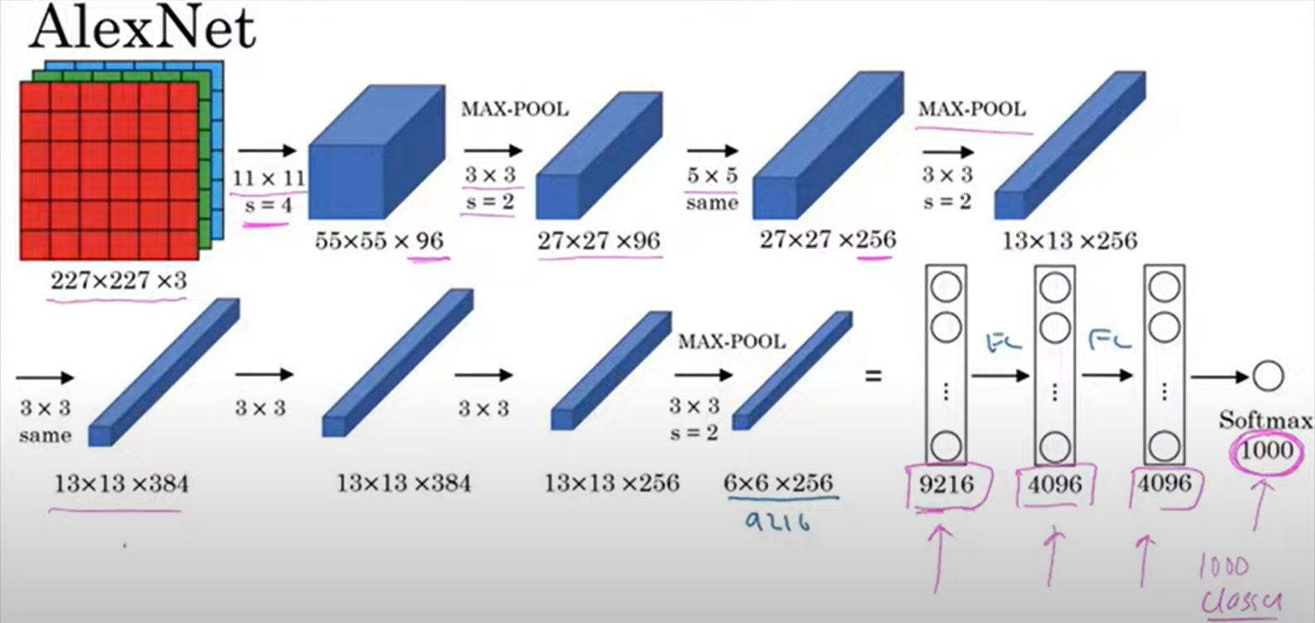

More pretrained models are :

Vggnet

Resnet